Experiment 1
AIM: To implement basic Logic Gates (NOT, AND, OR)
APPARATUS: https://circuitverse.org/simulator
PROCEDURE:
- NOT GATE
The NOT gate is a single input single output gate. This gate is also known as Inverter because it performs the inversion of the applied binary signal, i.e., it converts 0 into 1 or 1 into 0.

Input (A) | Output (B)
0 | 1
1 | 0

Expression: B= A

- AND GATE
A Boolean operator which gives the value 1 if and only if all the operands are 1, and otherwise has a value of zero.

Inputs | Outputs

A | B | C
1 | 0 | 0
0 | 1 | 0
0 | 0 | 0
1 | 1 | 1

Expression: C= A.B

- OR GATE
A logical operation which gives the value 1 if at least one operand has the value 1, and otherwise gives a value of zero.

Inputs | Outputs

A | B | C
0 | 1 | 1
1 | 0 | 1
1 | 1 | 1
0 | 0 | 0

Expression: C= A+B

NOT GATE Diagrams:

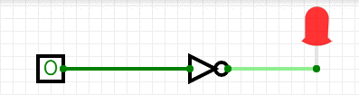
3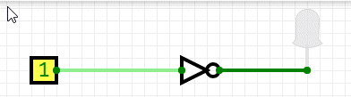

AND GATE Diagrams:
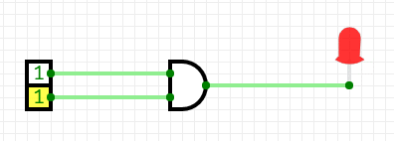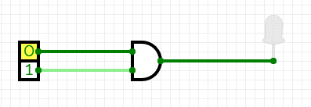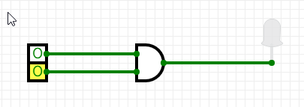

OR GATE Diagrams:

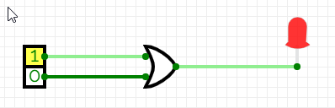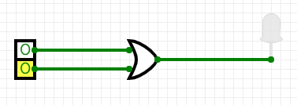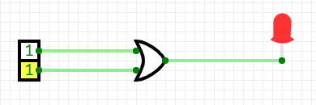

Experiment 2
AIM: To implement basic Logic Gates (NAND, NOR)
APPARATUS: https://circuitverse.org/simulator
PROCEDURE:
- NAND GATE
A Boolean operator which gives the value 0 if and only if all the operands have a value of 1, and otherwise has a value of one (equivalent to NOT AND).
Inputs | Outputs

A | B | C
0 | 0 | 1
0 | 1 | 1
1 | 0 | 1
1 | 1 | 0

Expression: C= A.B
- NOR GATE
A Boolean operator which gives the value 1 if and only if all operands have a value of 0 and otherwise has a value of zero.
Inputs | Outputs

A | B | C
0 | 0 | 1
0 | 1 | 0
1 | 0 | 0
1 | 1 | 0

Expression: C= A+B

- EX-OR GATE
The EXOR gate has a high output only when an odd number of inputs are high. For the two input EXOR gates, the output will be high when the set of input is either 01 or 10.
Inputs | Outputs

A | B | C
0 | 0 | 0
0 | 1 | 1
1 | 0 | 1
1 | 1 | 0

Expression: C= A+B
- EX- NOR GATE
The output of EX-NOR gate is 1 when both the inputs are 1 (high) and if both the inputs are 0 (low). If either one of the input is 1 (high) the output will be 0 (low). In other words, both the inputs should be in the same logic level for the output to be 1.
Inputs | Outputs

A | B | C
0 | 0 | 0
0 | 1 | 1
1 | 0 | 1
1 | 1 | 0
Expression: C= A+B
NAND GATE Diagrams:
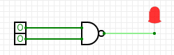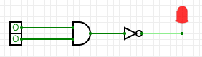

NOR GATE Diagrams:
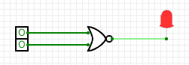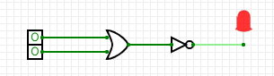
EX- OR GATE Diagrams:
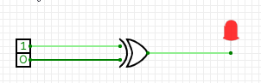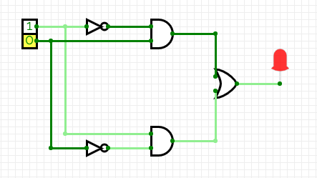
EX-NOR GATE Diagrams:
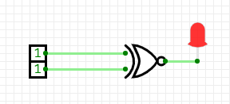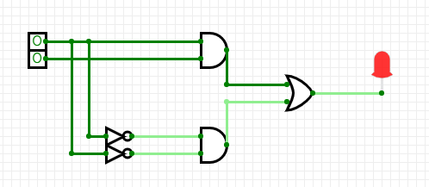
Experiment 3
AIM: To implement HALF ADDER
APPARATUS: https://circuitverse.org/simulator
PROCEDURE:
HALF ADDER
Half Adder is a combinational logic circuit which is designed by connecting one EX-OR gate and one AND gate. The half adder circuit has two inputs: A and B, which add two input digits and generates a carry and a sum.
Inputs | Outputs

A | B | Sum | Carry
0 | 0 | 0 | 0
0 | 1 | 1 | 0
1 | 0 | 1 | 0
1 | 1 | 0 | 1

Expression:
Sum = A+B
Carry = A.B

HALF ADDER Diagrams:
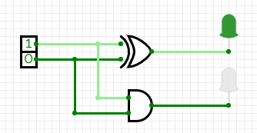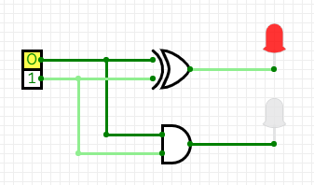
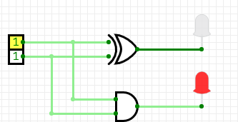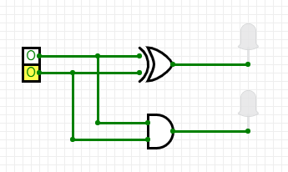
Experiment 4
AIM: To implement FULL ADDER
APPARATUS: https://circuitverse.org/simulator
PROCEDURE:
FULL ADDER
Full Adder is the adder which adds three inputs and produces two outputs which consists of two EX-OR gates, two AND gates and one OR gate.
Inputs | Outputs

A | B | Cin | Sum | Carry
0 | 0 | 0 | 0 | 0
0 | 0 | 1 | 1 | 0
0 | 1 | 0 | 1 | 0
0 | 1 | 1 | 0 | 1
1 | 0 | 0 | 1 | 0
1 | 0 | 1 | 0 | 1
1 | 1 | 0 | 0 | 1
1 | 1 | 1 | 1 | 1

Expression:
Sum= C+(A+B)
Carry=AB+C.(A+B)

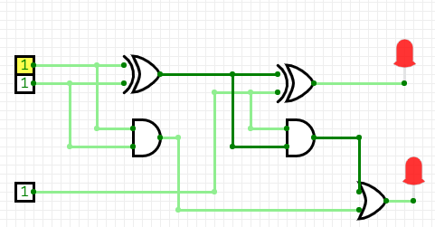
FULL ADDER Diagrams:

Assignment 5
AIM: To implement HALF SUBTRACTOR
APPARATUS: https://circuitverse.org/simulator
PROCEDURE:
HALF SUBTRACTOR
The Half-Subtractor is a combinational circuit which is used to perform subtraction of two bits. It has two inputs, A (minuend) and B (subtrahend) and two outputs Difference and Borrow. The logic symbol and truth table are shown below.
Inputs | Outputs

A | B | Difference | Borrow
0 | 0 | 0 | 0
0 | 1 | 1 | 1
1 | 0 | 1 | 0
1 | 1 | 0 | 0

Expression:
Sum = A+B
Carry = A.B

HALF SUBTRACTOR Diagrams:
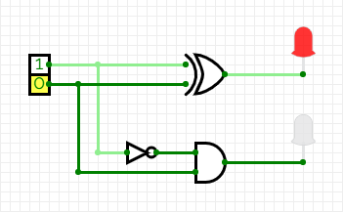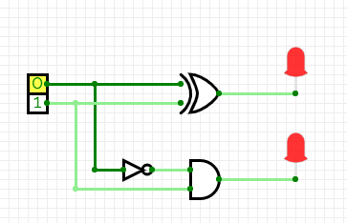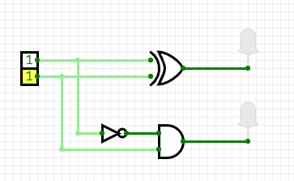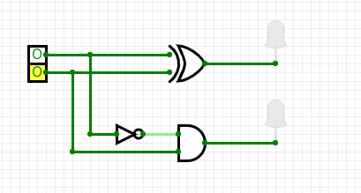
Assignment 6
AIM: To implement FULL SUBTRACTOR
APPARATUS: https://circuitverse.org/simulator
PROCEDURE:
FULL SUBTRACTOR
The full subtractor is a combinational circuit which is used to perform subtraction of three input bits: the minuend, subtrahend, and borrow in The full subtractor generates two output bits: the difference and borrow out .

Inputs | Outputs

A | B | Bin | Difference | Borrow
0 | 0 | 0 | 0 | 0
0 | 0 | 1 | 1 | 0
0 | 1 | 0 | 1 | 0
0 | 1 | 1 | 0 | 1
1 | 0 | 0 | 1 | 0
1 | 0 | 1 | 0 | 1
1 | 1 | 0 | 0 | 1
1 | 1 | 1 | 1 | 1

Expression:
$$Sum=C⨁(A⨁B)$$
$$Carry=A^{'}B+C.(A^{'}+B)$$

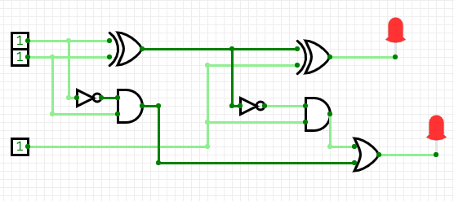

Assignment 7
AIM: To implement SR FLIP/FLOP
APPARATUS: https://circuitverse.org/simulator
PROCEDURE:
SR FLIP/FLOP
SR flip flop, also known as SR latch is the basic and simplest type of flip flop. It is a single bit storage element. It has only two logic gates. The output of each gate is connected to the input of another gate. The SR flip flop can be constructed by using NAND gates or NOR gates.

S | R | Q | Q’ | State
0 | 0 | 0 | 0 | NO CHANGE
0 | 0 | 1 | 1 | NO CHANGE
0 | 1 | 0 | 0 | RESET Q>>0
0 | 1 | 1 | 0 | RESET Q>>0
1 | 0 | 0 | 1 | SET Q>>1
1 | 0 | 1 | 1 | SET Q>>1
1 | 1 | 0 | X | INVALID
1 | 1 | 1 | X | INVALID

Characteristic Expression:
Q_{n+1} = S + R Q_{n}

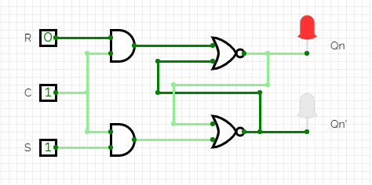

Experiment 8
AIM: To implement JK FLIP/FLOP
APPARATUS: https://circuitverse.org/simulator
PROCEDURE:
JK FLIP/FLOP
A JK flip-flop is a sequential bi-state single-bit memory device named after its inventor by Jack Kil. In general it has one clock input pin (CLK), two data input pins (J and K), and two output pins (Q and Q̅).

K | J | Q | Q’ | State
0 | 0 | 0 | 0 | NO CHANGE
0 | 0 | 1 | 1 | NO CHANGE
0 | 1 | 0 | 0 | RESET Q>>0
0 | 1 | 1 | 0 | RESET Q>>0
1 | 0 | 0 | 1 | SET Q>>1
1 | 0 | 1 | 1 | SET Q>>1
1 | 1 | 0 | 1 | TOGGLE
1 | 1 | 1 | 0 | TOGGLE

Characteristic Expression:
$$Qn+1 = T\overline{Qn} + \overline{T}Qn$$
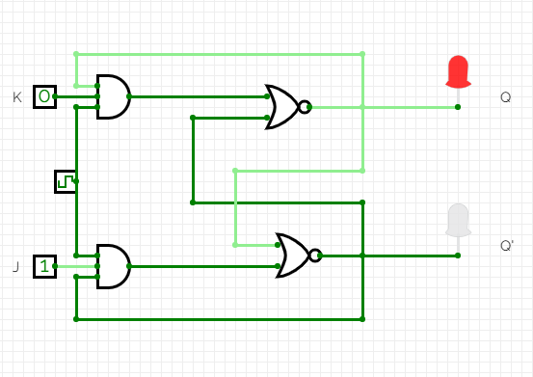
Experiment 9
AIM: To implement SIPO (Serial In Parallel Out) Register
APPARATUS: https://circuitverse.org/simulator
PROCEDURE:
SIPO (Serial In Parallel out)
The shift register, which allows serial input (one bit after the other through a single data line) and produces a parallel output is known as Serial-In Parallel-Out shift register.

Working:
Input is 110 i.e. 3 bits

Clock | I/P | Q₂ | Q₁ | Q₀
0 | 0 | 0 | 0 | 0
1 | 0 | 0 | 0 | 0
2 | 1 | 1 | 0 | 0
3 | 1 | 1 | 1 | 0

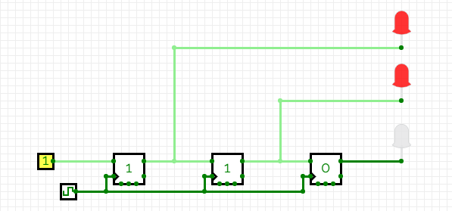

Experiment 10
AIM: To implement SISO (Serial In Serial Out) Register
APPARATUS: https://circuitverse.org/simulator
PROCEDURE:
SISO (Serial In Serial out)
The shift register, which allows serial input (one bit after the other through a single data line) and produces a serial output is known as Serial-In Serial-Out shift register. Since there is only one output, the data leaves the shift register one bit at a time in a serial pattern, thus the name Serial-In Serial-Out Shift Register.

Working:
Input is 110 i.e. 3bits

Clock | I/P | Q₂ | Q₁ | Q₀
0 | 0 | 0 | 0 | 0
1 | 0 | 0 | 0 | 0
2 | 1 | 1 | 0 | 0
3 | 1 | 1 | 1 | 0
4 | _ | _ | 1 | 1
5 | _ | _ | _ | 1

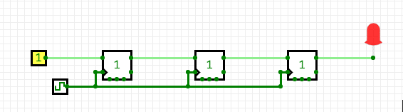

Experiment 11
AIM: To implement Multiplexer using logic gates
APPARATUS: https://circuitverse.org/simulator
PROCEDURE:
Multiplexer (using logic gates)
A digital multiplexer is similar to a multi-position switch with many inputs and only one output. It has control inputs to select a particular input. It is also called as a channel selector and abbreviated as Mux.

It is easier to build multiplexers using gates (small scale integration -SSI ICs) for a few select lines. But as the number of select lines increases, use of medium scale integration MSI ICs becomes the best choice.
A multiplexer can be designed using: a. basic logic gates b. universal gates (NAND & NOR).

Truth Table:
S₀ | S₁ | Output
0 | 0 | I₀
0 | 1 | I₁
1 | 0 | I₂
1 | 1 | I₃

4x1 MUX Diagram:
Io comes as Output, when So&S1 is equal to zero

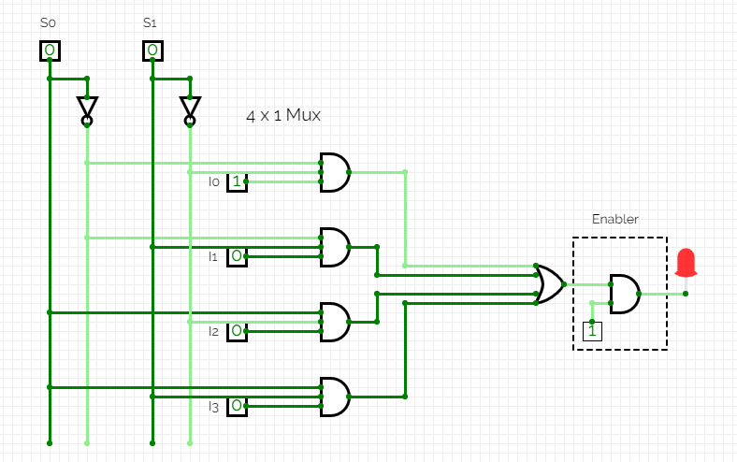
Experiment 12
AIM: To implement De-Multiplexer using logic gates
APPARATUS: https://circuitverse.org/simulator
PROCEDURE:
De-Multiplexer (using logic gates)
A demultiplexer (also known as a demux or data distributor) is defined as a circuit that can distribute or deliver multiple outputs from a single input. A demultiplexer can perform as a single input with many output switches.
The demultiplexer’s output lines are ‘n’ in number, the select line number is ‘m’ and n = 2^{m}. The control signal or select input code decides the output line to which the input has to be transmitted.

Truth Table:
Input | Select Lines |  | Output lines
I | S₁ | S₀ | D₀ | D₁ | D₂ | D₃
I | 0 | 0 | 1 | 0 | 0 | 0
I | 0 | 1 | 0 | 1 | 0 | 0
I | 1 | 0 | 0 | 0 | 1 | 0
I | 1 | 1 | 0 | 0 | 0 | 1

De-Mux Diagram:
D_{0,} D₁, D₂, D₃ comes as Output 0,0,1,0 respectively, when input data is 1 only, with selection line values 1 and 0.
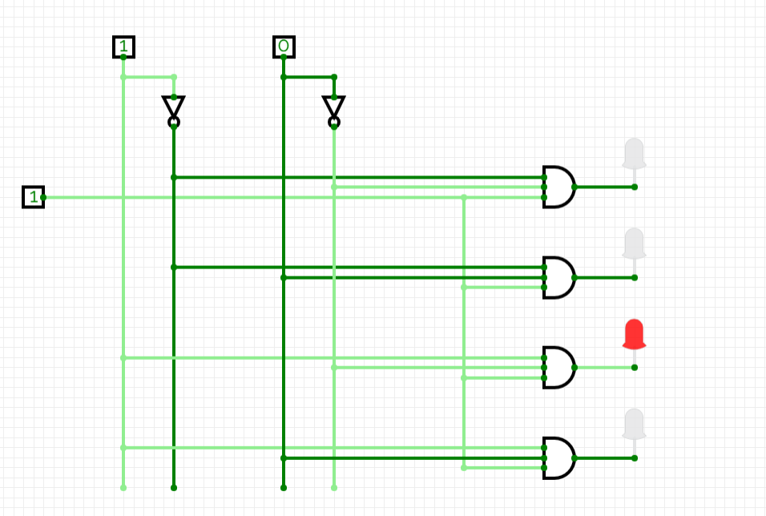
Experiment 13
AIM: To implement 3X8 Decoder using logic gates
APPARATUS: https://circuitverse.org/simulator
PROCEDURE:
Decorder (using logic gates)
A binary decoder (sometimes referred to as just a “decoder”) is a combinational logic circuit that converts binary information from the n coded inputs to a maximum of 2^{n} unique outputs. Binary decoders are used in an extensive number of applications—notably data multiplexing and data demultiplexing and seven segment displays.

3X8 Decoder Truth Table:
Inputs |  |  |  | Outputs
A | B | C | D₀ |  | D₁ | D₂ | D₃ | D₄ | D₅ | D₆ | D₇
0 | 0 | 0 | 1 |  | 0 | 0 | 0 | 0 | 0 | 0 | 0
0 | 0 | 1 | 0 |  | 1 | 0 | 0 | 0 | 0 | 0 | 0
0 | 1 | 0 | 0 |  | 0 | 1 | 0 | 0 | 0 | 0 | 0
0 | 1 | 1 | 0 |  | 0 | 0 | 1 | 0 | 0 | 0 | 0
1 | 0 | 0 | 0 |  | 0 | 0 | 0 | 1 | 0 | 0 | 0
1 | 0 | 1 | 0 |  | 0 | 0 | 0 | 0 | 1 | 0 | 0
01 | 1 | 0 | 0 |  | 0 | 0 | 0 | 0 | 0 | 1 | 0
1 | 1 | 1 | 0 |  | 0 | 0 | 0 | 0 | 0 | 0 | 1

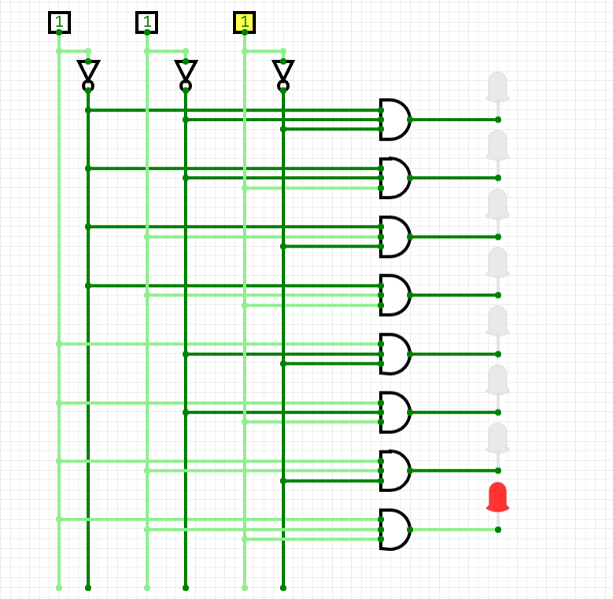
3X8 Decoder Diagram:

